Client / Owner: | Wentworth Condominium Corporation No. 23 c/o Wilson Blanchard Management
Contractor: | GRRC Roofing
Materials: | 24 ga prefinished (black) metal flashing, 22 ga galvanized hook strip

Pretium was on site to review work in progress and completed to date. Only items visible at the time of the site visit and at locations outlined below have been reviewed. The following was observed / discussed:
Observations / Comments
- General
  - Project Status: 97% complete
  - Original Estimated Project Completion Date: April 30, 2024, as agreed to at pre-con meeting.
  - Projected Completion Date: Currently on schedule.
  - Staging area has been demobilized (Photograph 1). GRRC vehicles were parked in visitor parking at south end of the building.
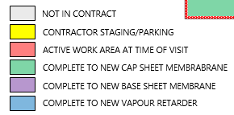
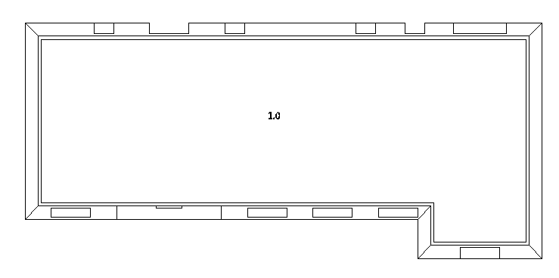
KEY PLAN
- Section 1.0
  - Pretium reviewed schedule with Foreman onsite. Foreman advised he anticipates metal work will be complete by end of the day.
  - Standing water was observed along the east and west perimeters of the roof (Photograph 2), but the roof was still in the process of draining from heavy rain the previous night. The roof will be reviewed again at the final walkover to determine if any remediation is required. If required, remediation will be paid for from the $10,000 contingency in the contract.
  - New prefinished metal flashings were measured to be 24 gauge as specified (Photograph 3). New prefinished metal flashings are black as confirmed at the preconstruction meeting.
  - New galvanized metal hook strips were measured to be 22 gauge as specified (Photograph 4).
  - New prefinished metal covers were being installed at all scupper collector heads (Photograph 5).
  - New galvanized metal hook strip was being secured in an up/down pattern at approx. 6” O.C. (Photograph 6).
  - New metal fascia and cap were being installed in approx. 8’ lengths with staggered S-lock end joints (Photograph 7). Contractor confirmed corner joints at cap will be standing seam and interior face of cap will be secure at 24” O.C. with colour matched screws.
  - New 4-1/2” x 3” downspouts were being installed at time of visit (Photograph 8). Pretium and contractor agreed downspouts will be secured with strapping at top and bottom of mansard and top and bottom of masonry wall. Pretium confirmed where downspouts are not currently connected to the weeping system, they are to extend out a min. 2’-3’ at the base to prevent water from pooling on the foundation walls (Photograph 9). Pretium and Contractor reviewed downspout passing through lower shingle roof (Photograph 10) and agreed to leave portion of existing downspout passing through roof in place and provide appropriate transitions to new into (above) and out of (below) same. Contractor to ensure all openings through the lower roof at the remaining existing portion of downspout are well sealed.

 | 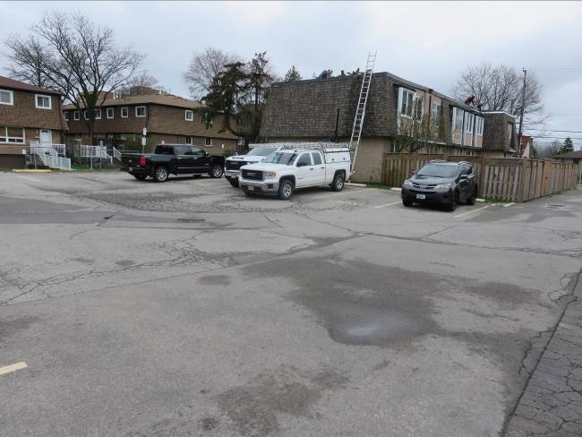 | 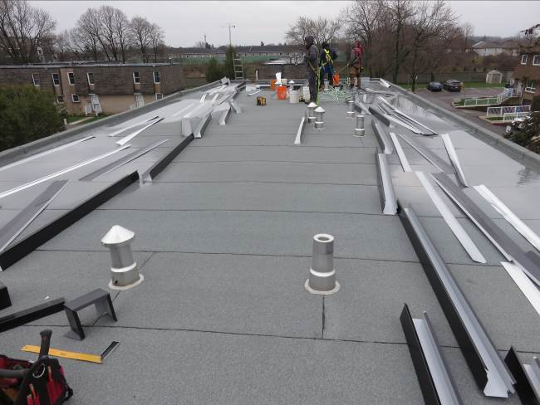
 | - Staging area has been demobilized. | - Standing water observed along east and west perimeter.
 | 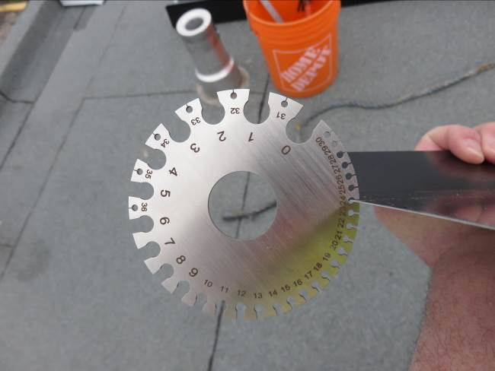 | 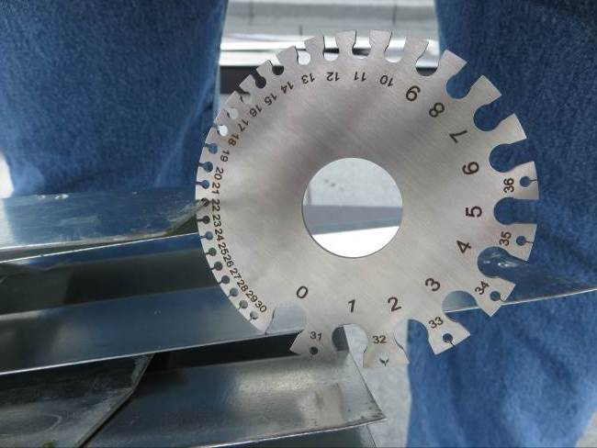
 | - New prefinished metal flashings measured at 24 ga. | - New metal hook strips measured at 22 ga.
 | 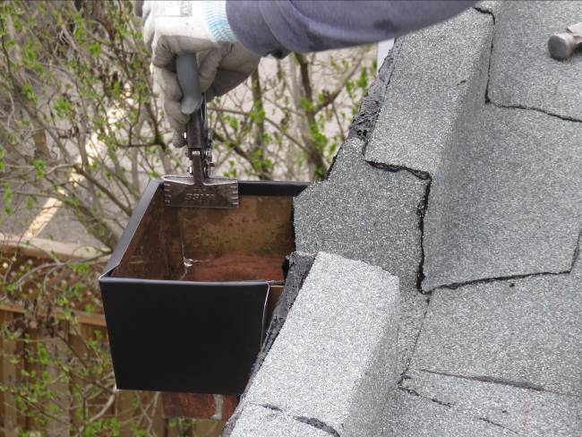 | 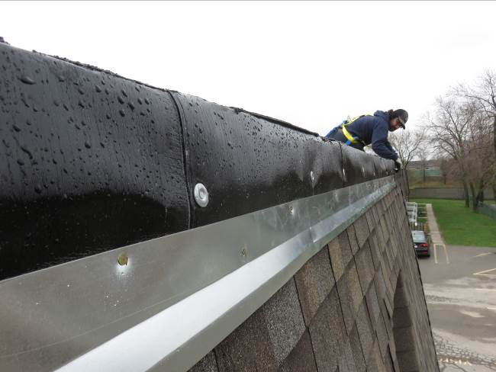
 | - New prefinished metal cover being installed at scupper collector head (Typ.). | - New galvanized hook strip secured in up/down pattern at approx. 6” O.C.
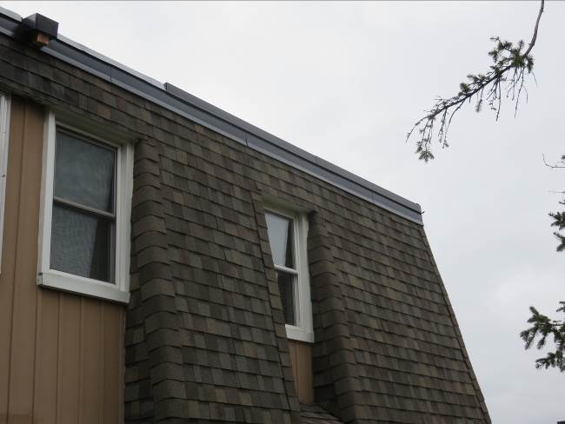 |  | 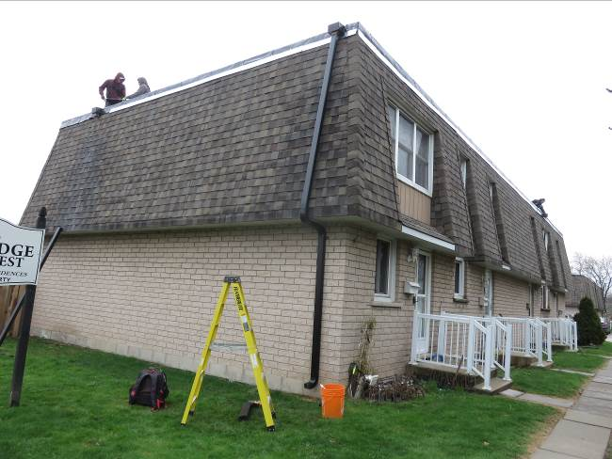
- New prefinished metal fascia (red) and cap (green). |  | - New 4-1/2” x 3” downspouts being installed.
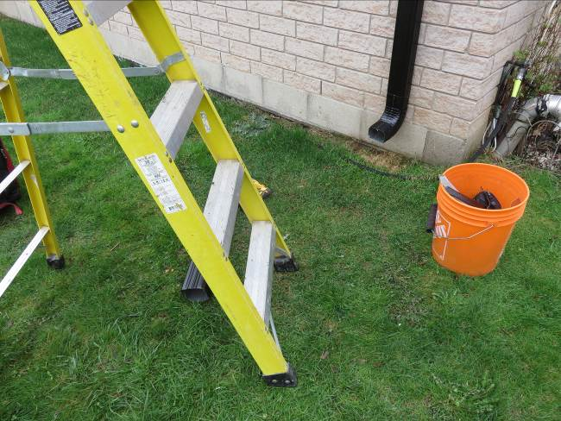 |  | 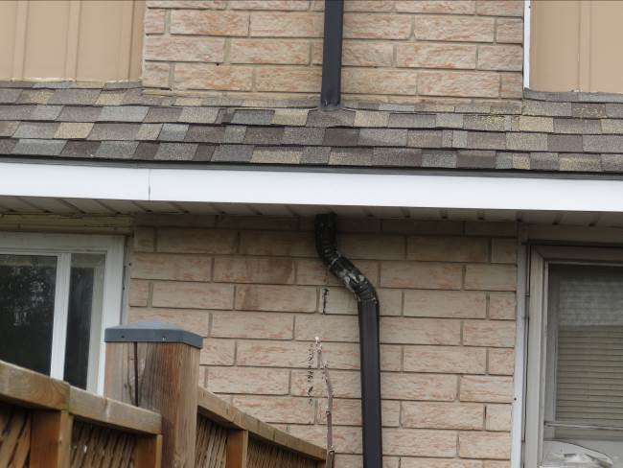
- New downspouts to extend out min. 2’-3’ away from foundation walls. |  | - Existing downspout passing though lower shingle roof.

This report was issued to all parties on November 8, 2026.
Trade foreman was verbally notified of report contents. This report pertains to work specifically requested and comments only on operations and items that were visible or being undertaken at the time of our inspection.
Report by: | Dave Neal, H.Dipl.T., RRO

